API Document

1. Get All Records:

**URL:** <http://localhost/codilar/codilarapp/index.php/apicontroller/getallrecords>

**Response:**

{

"records": [

{

"id": "1",

"companyname": "Maruti Suzuki",

"model": "Omni",

"image": "http://localhost/codilar/codilarapp/static/images/omni.jpg",

"status": "1",

"created_date": "2018-10-14 17:08:55",

"updated_date": "2018-10-14 17:08:55",

"isdeleted": "0"

},

{

"id": "2",

"companyname": "Ford",

"model": "Aspire",

"image": "http://localhost/codilar/codilarapp/static/images/aspire.jpg",

"status": "1",

"created_date": "2018-10-14 17:12:55",

"updated_date": "2018-10-14 17:12:55",

"isdeleted": "0"

},

{

"id": "3",

"companyname": "BMW",

"model": "3 series",

"image": "http://localhost/codilar/codilarapp/static/images/3series.jpg",

"status": "1",

"created_date": "2018-10-14 17:18:22",

"updated_date": "2018-10-14 17:18:22",

"isdeleted": "0"

}

],

"status": "Success",

"code": 200

}

**Postman View:**

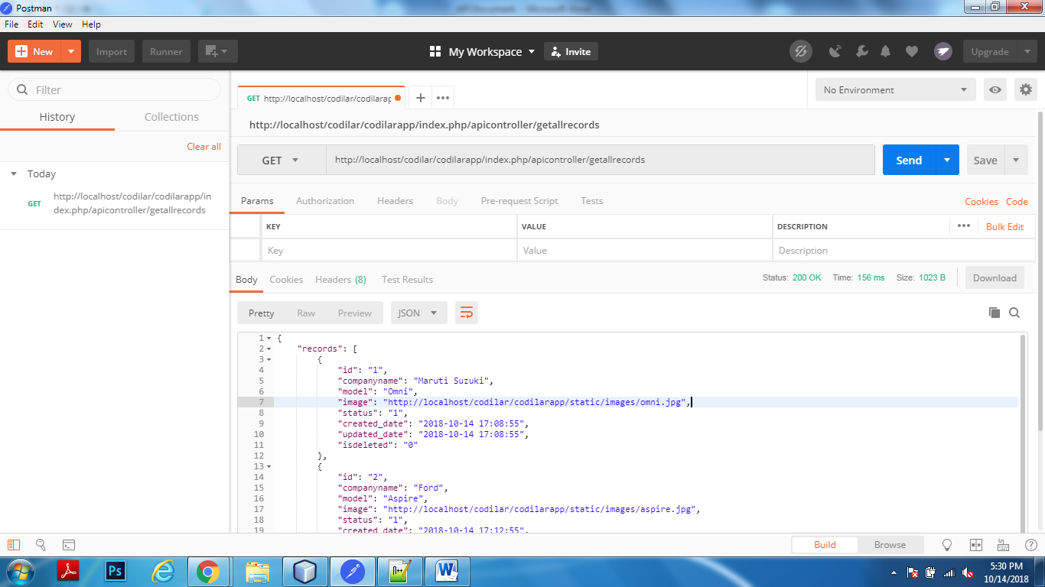

1. Get a Record:

**URL:** <http://localhost/codilar/codilarapp/index.php/apicontroller/getrow/3>

**Response:**

{

"row": {

"id": "3",

"companyname": "BMW",

"model": "3 series",

"image": "http://localhost/codilar/codilarapp/static/images/3series.jpg",

"status": "1",

"created_date": "2018-10-14 17:18:22",

"updated_date": "2018-10-14 17:18:22",

"isdeleted": "0"

},

"status": "Success",

"code": 200

}

**Postman:**

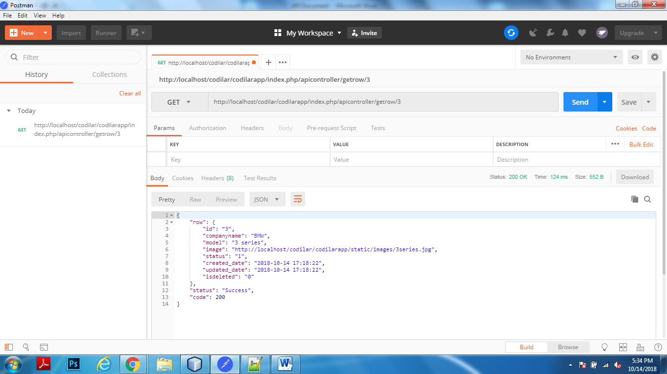

1. Add a Records:

**URL:** <http://localhost/codilar/codilarapp/index.php/apicontroller/postcar/>

**Response:**

{

"status": "Success",

"code": 200

}

**Postman:**

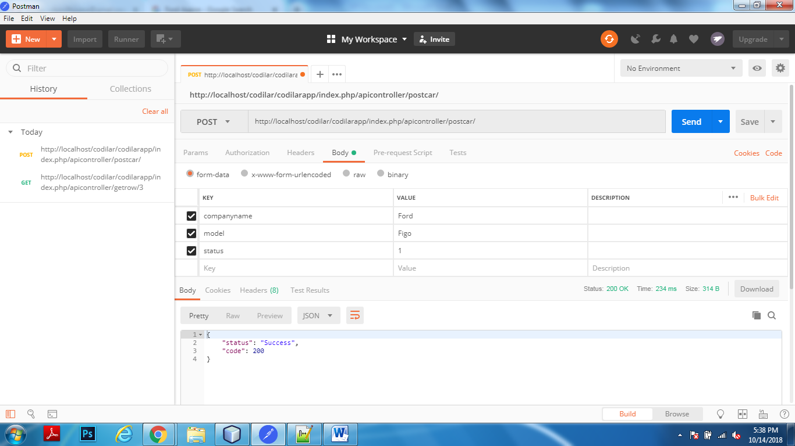

1. Edit a Record:

**URL:** http://localhost/codilar/codilarapp/index.php/apicontroller/postupdatecar/

**Response:**

{

"status": "Success",

"code": 200

}

**Postman:**

